

**GUJRAT TECHNOLOGICAL UNIVERSITY**



Chandkheda, Ahmedabad



**L. D. COLLEGE OF ENGINEERING**

A PROJECT REPORT ON

## REMOTE CONTROL MOPPING MACHINE

UNDER PROJECT OF DESIGN ENGINEERING –2B BE SEMESTER – 6TH

#### (MECHANICAL ENGINEERING)

|  |  |  |
| --- | --- | --- |
| **SR.**  **NO.** | **NAME OF STUDENT** | **ENROLLMENT NO** |
| 1 | AMBALIYA AADIL AARIFBHAI | 220283119002 |
| 2 | CHOTALIYA TRIBHOVAN HASMUKHBHAI | 220283119005 |
| 3 | FULWALA AHEMADRAZA MUSABHAI | 220283119008 |
| 4 | JETHVA VISHAL PRAVINBHAI | 220283119013 |

**GUIDE: -** K. A. PATEL EXTERNAL EXAMINER H.O.D.: V.B. PATEL

## ACKNOWLEDGEMENT

The success and final outcome of this project required a lot of guidance and assistance from many people and I am extremely privileged to have got this all along the competition along of our project. All that we have done is only due to such supervision and assistance and I would not forget to thank them.

I respect and thank of our guide **Prof.K.A.PATEL…**for providing us an opportunity to do the project work in (L. D. COLLAGE OF ENGINEERING, AHEMDABAD) and giving us all support and guidance for complete the project. I am extremely thankful to him for providing such a nice support and guidance, also he had busy schedule managing the corporate affairs.

I am thankful to and fortunate enough to get constant encouragement, support and guidance from all teaching staff of mechanical department which helped us in successfully completing our project work. Also I would like to extend our sincere esteems to all staffs in laboratory for timely support.

**Project associates**

1. **AMBALIYA AADIL AARIFBHAI**
2. **CHOTALIYA TRIBHOVAN HASMUKHBHAI**
3. **FULWALA AHEMADRAZA MUSABHAI**
4. **JETHVA VISHAL PRAVINBHAI**

INDEX

|  |  |  |
| --- | --- | --- |
| **Sr. No.** | **Topic** | **Page No.** |
| **1** | Abstract | 01 |
| **2** | Introduction | 02 |
| **3** | AEIOU Summary | 03 |
| **4** | Mind mapping canvas | 06 |
| **5** | Empathy canvas | 08 |
| **6** | Ideation Canvas | 11 |
| **7** | Product Development Canvas | 13 |
| **8** | Learning Needs Matrix | 16 |
| **9** | Components and model photos | 18 |
| **10** | Prototyping and component cost | 21 |
| **11** | Future scope | 22 |
| **12** | References | 23 |
| **13** | Logbook | 24 |

## ABSTRACT

#### This abstract is providing an overview of an innovative remote control mopping machine. The project "Remote Control Mopping Machine" endeavors to create a cutting-edge robotic system tailored for automated floor cleaning. With a focus on user convenience and efficiency, this system integrates advanced sensors and algorithms to navigate indoor spaces adeptly, ensuring comprehensive coverage and obstacle avoidance. One of its standout features is the incorporation of remote control functionality, enabling users to command the machine from a distance, thereby enhancing flexibility and ease of operation. By leveraging high-quality mopping components and intelligent algorithms, the system guarantees effective removal of dirt and grime from various floor surfaces while optimizing energy consumption. Designed with user-friendliness in mind, the machine boasts an ergonomic layout and intuitive interfaces, catering to a diverse array of users. Through these innovations, the project aims to deliver a remote-controlled mopping solution that redefines convenience and performance for both residential and commercial settings.

1

INTRODUCTION

In the realm of household chores, cleaning often stands out as a task demanding time and effort. With the continuous advancement of technology, there arises a perpetual quest for innovations that can streamline these processes, offering convenience and efficiency to users. In response to this need, our project delves into the development of a remote-controlled mopping machine-a cutting-edge solution designed to revolutionize the way we approach floor cleaning in residential settings.

This project emerges at the intersection of robotics and home maintenance, aiming to create a device that not only simplifies the cleaning process but also enhances its effectiveness. Traditional mopping methods often entail manual labor and repetitive motions, which can be both laborious and time-consuming. By leveraging the capabilities of robotics and remote-control technology, our aim is to introduce a novel approach that automates and optimizes the mopping task, ultimately providing users with more leisure time and a cleaner living environment.

Through this report, we will delve into the various aspects of our project, from its conceptualization and design to the implementation and testing phases. We will discuss the underlying technologies utilized in the development of the remote-controlled mopping machine, including sensors, actuators, and control systems. Additionally, we will explore the considerations considered during the design process, such as maneuverability, adaptability to different floor surfaces, and user interface design.

Ultimately, our endeavor seeks to offer not just a technical solution but a practical and transformative tool that addresses the evolving needs of modern households. By introducing a remote-controlled mopping machine, we aim to contribute to the ongoing discourse on smart home technologies while making a tangible difference in the everyday lives of users.

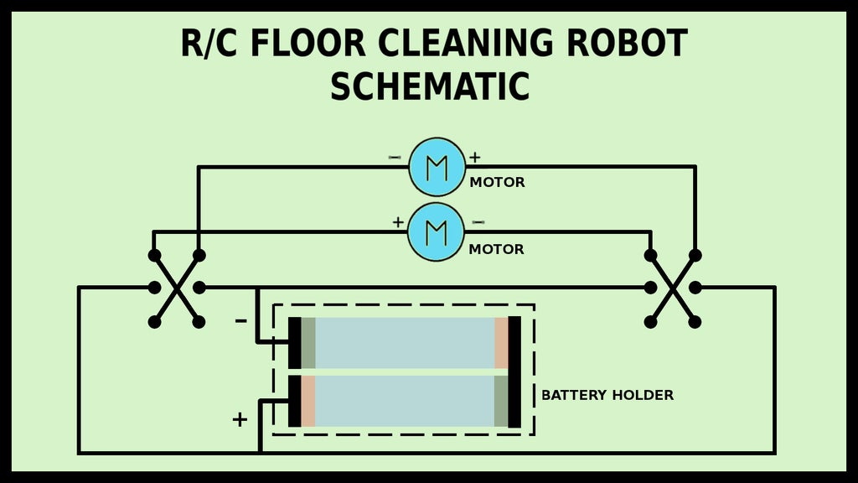

AEIOU Summary

The AEIOU summary canvas contains 5 Sections: 1.) Activity

2.) Environment

3.) Interaction

4.) Object

5.) User

1.) ACTIVITY:

* Consult a manufacturer.
* Meet the professor.
* Reading reference books.
* Take feedback from sweeper man.
* Visit DC motor manufacturing industry.
* Brainstorming.

2.) ENVIRONMENT:

* Dusty
* Polluted
* Monsoon
* Autumn
* Public spots

3.) INTERACTION:

* Student Engineer
* Student Sweeper man
* Student DC motor manufacture
* Student Corporation

4.) OBJECTS:

* Gear TT motor
* Base plate
* Remote controller
* Pump
* Scrubbing pad
* Battery
* Water tank

5.) USERS:

* + - Sweeper man
    - Housekeeping staff
    - Municipal corporation
    - Older age person
    - Disabled person
    - Hosteller

# MIND MAPPING CANVAS

**1.)** ACTIVITY

* + - Consult a manufacturer.
    - Meet the professor.
    - Reading reference books.
    - Brainstorming.
    - Take feedback from sweeper man.
    - Visit DC motor manufacturing industry.

**2.)** Benefits

* + - Faster operation
    - Less time required for cleaning
    - Efficient cleaning
    - Reduce human effort

**3.)** equipment

* + - Gear TT motor
    - Remote controller
    - Battery
    - Scrubbing pad
    - Base plate
    - Pump

**5.)** driving mechanism

* + - Conversion from electrical energy to mechanical energy
    - Motorized wheels for motion

**6.)** application

* + - Cleaning the floor area without human interaction
    - Cleaning in corporate offices and public spots
    - Cleaning in hospitals

# EMPATHY CANVAS

Empathy mapping canvas contain 4 sections:

1.) User

2.) Stakeholders

3.) Activity

4.) Story Boarding

1.) USERS:

* + - Sweeper man
    - Housekeeping staff
    - Older aged person

2.) STAKEHOLDERS:

* + - Gear TT motor manufacturer
    - Battery manufacturer
    - Water pump manufacturer

3.) ACTIVITIES:

* + - Consult a manufacturer.
    - Meet the professor.
    - Reading reference books.
    - Brainstorming.
    - Take feedback from sweeper man.
    - Visit DC motor manufacturing industry.

 STORY BOARDING

* + - * HAPPY

Consider Sarah, a working mother who tries to keep up with housework while earning for her children, mopping the floor frequently takes a backseat, leaving her concerned about spills and sailed appearance.

* + - HAPPY

With help of remote-control mopping machine, mrunal can now clean dirt under furniture and corner with comfort of her couch while his son plays. Now she has more time for relax and play with her children during cleaning the home.

* + - SAD

Consider an old men named Arthur who lives alone. He takes care to keeping his home, but he bends down to wipe the floors which is very difficult for him.

* + - SAD

Mohan’s present housekeeping staff leaves the floor moist and slick which makes him concerned about falling. Mohan is looking for a solution to keep his home tidy without jeopardizing his safety. Remote-control mopping machine could be solution for his problem.

# IDEATION CANVAS

Ideation canvas contain 4 sections: 1.) People

2.) Activities

3.) Situation/Context/Location

4.) Props/Possible Solution

1.) PEOPLES:

* + - Sweeper man
    - Housekeeping staff
    - Older aged person
    - Disabled person
    - Hostellers

2.) ACTIVITIES:

* + - Consult a manufacturer.
    - Meet the professor.
    - Reading reference books.
    - Brainstorming.
    - Take feedback from sweeper man.
    - Visit DC motor manufacturing industry.

3.) SITUATION/CONTEXT/LOCATION:

* + - Daily cleaning / remove dust & foreign particles / Residential area
    - Cleaning larger floor/ time saving / industry or factory
    - Cleaning platforms/ less human effort / railway station

4.) PROPSIBLE:

* + Mobile operated mopping machine.
  + Remote control mopping machine.
  + Floor scrubber dryer machine.

11

# PRODUCT DEVLOPMENT CANVAS

* PEOPLES:
  + - Sweeper man
    - Housekeeping staff
    - Older aged person
    - Disabled person
    - Hosteller
* PURPOSE:
* To clean the floor
* To reduce human effort
* Effective and accurate cleaning

3.) PRODUCT FUNCTION:

* Our product typically sprays water or cleaning solution then scrubs the floor, vacuum up dirt and clean the floor

4.) PRODUCT FEATURES:

* Automatic cleaning
* Movement through remote control
* Scrubbing brushes
* Adjustable setting
* Drying feature

5.) COMPONENTS:

* + - Gear TT motor
    - Remote controller
    - Battery
    - Scrubbing pad
    - Base plate
    - Pump
    - Water tank

6.) CUSTOMER REVALIDATION:

* Require less efforts in cleaning
* No leakage of water
* Easily dryer than manual mopping

7.) REJECT, REDISGN, RETAIN:

* Retain

# LEARNING NEEDS MATRIX

1. TOOLS/METHODS/THEORIES/APPLICATION PROCESS INVOLVED
   * Flow regulator
   * Motorized wheel for motion
   * Conversion from electrical energy to mechanical energy.
2. SOFTWARE/SIMULATION/SKILLS/MATHEMATICALREQUIRMENTS
   * Solid-works
   * ANASY
   * Tinder CAD
3. COMPONENT/MATERIALS/STRENGTH CRITERIA (EXPLORATION-VARIETIES/TESTING REQUIREMENTS
   * Scrubbing pad – plastic mesh
   * Circuit – copper & silicon
   * Cleaning efficiency test
   * Remote control test
   * Visual inspection
4. APPLICABL STANDARDS AND SPECIFICATIONS/ PRINCIPLES AND EXPERIMENTS
   * Geometric dimensioning and tolerance
   * Iso 677: 1976

**MAIN COMPONENETS**

Scrubbing pad Gear TT motor

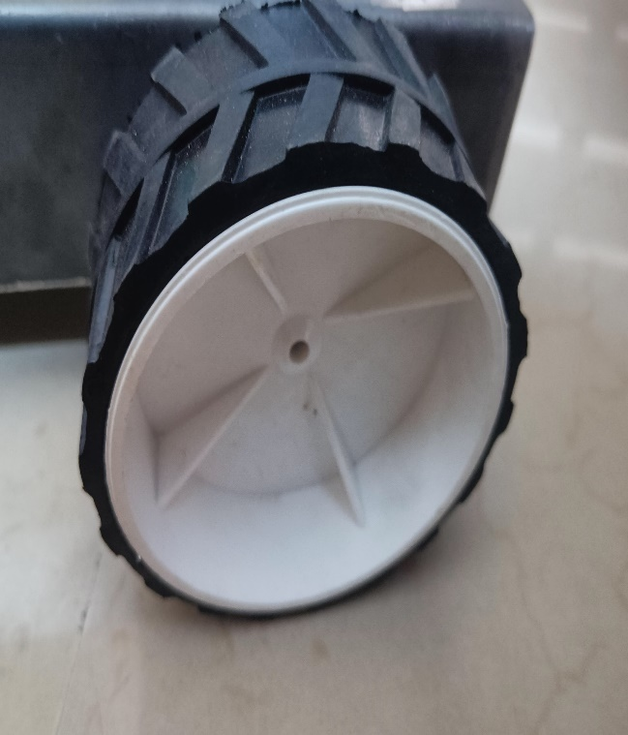

Water tank Wheels

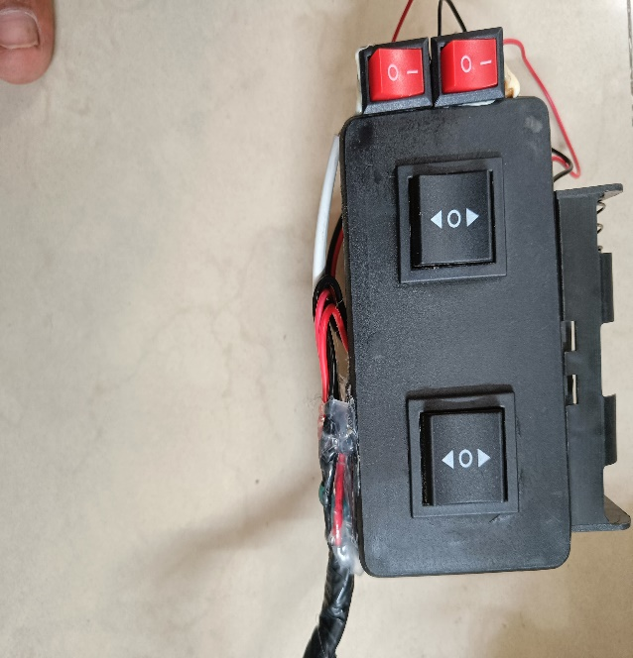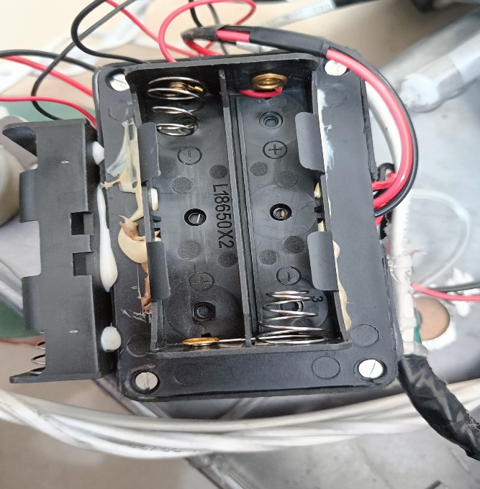

battery cell socket remote controller

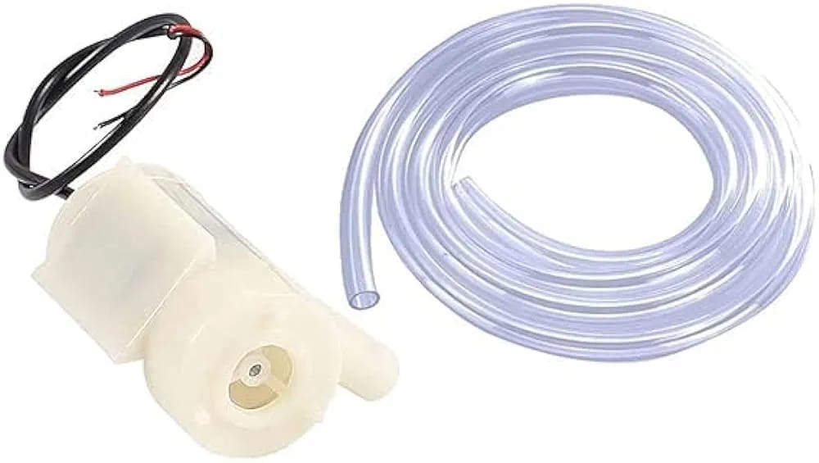

Water pump and tube

**CAD model and working prototype**

PROTOTYPING

* To prototype a remote-control mopping machine, first, clearly define the project's requirements, outlining factors like size, floor compatibility, battery life, and remote-control range. Next, conceptualize the design, considering how the mopping mechanism will function and integrate with remote control capabilities
* Select appropriate components such as motors, sensors, micro-controller, and batteries, ensuring they meet project specifications and are compatible.
* Test the prototype extensively on various floor types, identifying any shortcomings or areas for improvement. Iterate on the design based on testing feedback, refining components, code, and overall functionality.
* COMPONENT COST

|  |  |  |  |  |
| --- | --- | --- | --- | --- |
| NO. | COMPONENT NAME | QUANTITY | UNIT PRICE | PRICE (INR) |
| 1 | DC gear TT motor | 2 | 115 | 230 |
| 2. | Scrubbing pad | 2 | 50 | 100 |
| 3. | Water tank | 1 | 60 | 60 |
| 4. | Water pump and tube | 1 | 165 | 165 |
| 5. | Wheels | 4 | 25 | 100 |
| 6. | Battery cell (3.7v & 2000mah) | 2 | 40 | 80 |
| 7. | Remote controller | 1 | 280 | 280 |
| 8. | Battery cell socket | 1 | 25 | 25 |
| 9. | Base plate | 1 | 20 | 20 |
| 10. | Wire | 2 meters | 25/meter | 50 |

FUTURE SCOPE

.

* scope of remote-control mopping machines holds considerable potential for revolutionizing household and commercial cleaning practices. As technology continues to advance, these machines are poised to become more sophisticated, efficient, and accessible. One avenue of development lies in the integration of artificial intelligence and machine learning algorithms, enabling mopping machines to adapt to different floor surfaces, adjust cleaning patterns based on usage trends, and even autonomously navigate complex environments. Additionally, advancements in sensor technology could enhance the machines' ability to detect and avoid obstacles, prevent collisions, and ensure thorough cleaning coverage.
* The proliferation of smart home ecosystems presents opportunities for remote control mopping machines to seamlessly integrate with other connected devices, allowing for centralized control and automation. Furthermore, improvements in battery technology could extend operating times and reduce charging intervals, enhancing overall productivity and user convenience. With growing emphasis on sustainability, future iterations of these machines may prioritize eco-friendly cleaning solutions and materials, minimizing environmental impact.

**REFERENCES**

* <https://youtu.be/FpNmaW3-AcE?si=6OjlqjWUE8-YcRuV>
* <https://www.amazon.in/xcluma-Shaft-DC3V-6V-Motor-Smart/dp/B0974XG5TK/ref=sr_1_3?sr=8-3>
* REFERENCE BOOKS

PROJECT: REMOTE CONTROL MOPPING MACHINE

TEAM ID: 496783

LOGBOOK

|  |  |
| --- | --- |
| **Date** | **Task Description** |
| 19/01/2024 | Selection of Problem, Causes of Problem |
| 02/02/2024 | Prior Art of Solving this Problem Concept |
| 09/02/2024 | Concept of solving this problem |
| 16/02/2023 | List of different components |
| 01/03/2024 | Gathering Knowledge Components |
| 15/03/2024 | Design of Solution Model |
| 22/03/2023 | Gathering limitations of project |
| 05/04/2024 | Cost Comparison between  different Solution available in the market versus our project |
| 12/04/2024 | Preparation of Documents |
| 19/04/2024 | Final Submission |